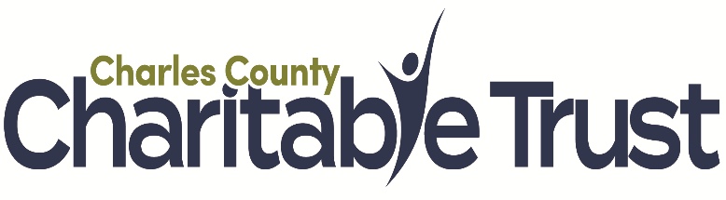
Application Access Question:

*Are you an organization/business currently operating in Charles County OR planning to operate in Charles County in 2025?

If you respond “no,” you are not eligible to apply for a grant. For more information, contact: cburnett@charlesnonprofits.org

Organization/Business Information

- Legal Name of Organization/Business

- Address

- Contact person

- Email

- Phone

- Website

- EIN #

- Year Established

- Have you received Project Restore Funds in the past?
What year? How much?

- Upload a copy of your business plan (optional)
Please note: A business plan will be required if you are awarded funding.

- Organization/Business Resume (350 word limit)
Describe the products or services offered by your business, employee roles, etc

- Number of Full-Time Staﬀ

- Number of Part-Time Staﬀ

- Amount of Grant Request (Max. $33,750)

- Preferred Property Address: (Check boxes)
- 101 Charles St, Ste 302, La Plata
- 406 Charles St, La Plata
- 2 Industrial Park Drive, Waldorf
- 3825 Leonardtown Rd, Waldorf
- 4445-4461 Crain Hwy, White Plains
- Other eligible property: (TEXT BOX)
You may search for eligible “sustainable communities” properties here: https://portal.dhcd.state.md.us/GIS/revitalize/index.html

- Property Intended Use
(350 word limit)

- Property Zoning Type

- Property Condition: (350 word limit)
Describe the current condition of the property. Describe any improvements/renovations required to open your business.

- Is this a historic property? (yes/no check box)

- Property Square Footage:

- Monthly rent:

- Property owner/landlord name and phone number:

- Timeline (350 word limit)
Provide a timeline of project (space must be open and operational by 12/31/25)

- Scalability (150 word limit)
If your request is not fully funded, will your business still be able to complete the project?

- Sustainability (150 word limit)
Does your business have a plan to sustain your use of this space after the conclusion of this grant?

Financial Information

- Start Date of Current Fiscal Year

- Current Fiscal Year Budget (PDF or Excel format)

- Prior Fiscal Year Operating Budget vs Actuals (PDF or Excel format)

- Proposed Project Budget Template

Download the Proposed Program Budget Template by clicking here. Once completed, upload it to the box below.

- Sources of other Project Funding (300 word limit)
Are there other sources of funding for this project? List amounts/sources/commitments.

- List all architects, contractors, others being used to complete this project (350 word limit)

- Program Budget Narrative (350 word limit)

- Upload most recent Audit, 990, or related federal tax return filing (PDF format)

- Application Contact

- Email

- Phone

- Managing Head of Organization/Business

  - Email

  - Phone

