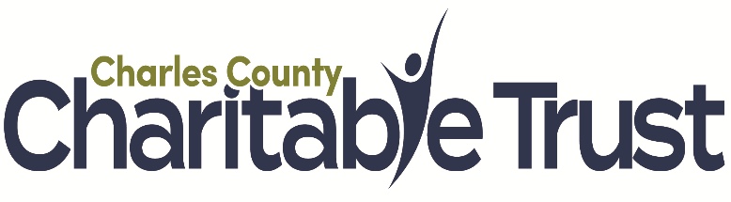

- Are you an IRS recognized 501(c)(3) tax-exempt organization operating in Charles County?

- Will your proposed program activities be carried out for the beneﬁt of Charles County residents?

- If your organization has been operational for at least three full years, is it operating with an annual budget and a board that consists of at least three volunteer board members who are not related?

- If you respond “no” to any of these questions, you are not eligible to apply for a grant. For more information, contact: cburnett@charlesnonprofits.org

Organization Information

- Legal Name of Organization

- Address

- Email

- Phone

- Website

- EIN #

- Year Organization Was Established

- Please select the years you have received prior grants from Charles County Charitable Trust

- FY23 Grant Amount

- FY23 Purpose (30 word limit)

- FY22 Grant Amount

- FY22 Purpose (30 word limit)

- FY21 Grant Amount

- FY21 Purpose (30 word limit)

- Please select the years you have received grants or funding directly from Charles County government, in addition to or instead of grants from the Charles County Charitable Trust.

- FY23 Grant Amount

- FY23 Purpose (30 word limit)

- FY22 Grant Amount

- FY22 Purpose (30 word limit)

- FY21 Grant Amount

- FY21 Purpose (30 word limit)

- IRS 501(c)(3) Determination Letter (PDF format)

- Current Certiﬁcate of Status provided by the Maryland State Department of Assessments and Taxation (PDF format) (Click HERE to obtain a copy of your certificate of status) https://dat.maryland.gov/businesses/Pages/Internet-Certificate-of-Status.aspx

- Organization Resume
What are your organization’s mission, goals, history and recent accomplishments? Include information about your organization’s demonstrated capacity to meet institutional and project objectives, including expertise of staff and volunteers (350 word limit)

- Number of Full-Time Staﬀ

- Number of Part-Time Staﬀ

- Number of Volunteers, Including Board Members

- Is this number an estimate?

- Number of Volunteer Hours in the Most Recent Fiscal Year

- Is this number an estimate?

- Board of Directors, Titles, and Affiliations or Former Affiliations (PDF format)

Program Information
If you serve multiple counties, provide information for Charles County only

- Purpose of Proposed Program (30 word limit)

- Number of Individuals to be Served in Charles County

- If you entered zero, please provide an explanation (30 word limit)

- Amount of Grant Request (Max. $65,000)

- Program Summary
Describe your grant request, including your overall goal(s), target population(s), and benefits to the people of Charles County. (350 word limit)

- Need
What problem or need does your grant request address? Describe the extent of the need or problem and provide evidence to substantiate it. (250 word limit)

- Objectives and Outcomes
What are the specific objectives of your grant request, including the number of people you expect to serve? What results are you committed to achieving? What evidence will prove your success? What impact will your program have on the individuals you serve? (350 word limit)

- Partnerships
List partner organizations specific to your grant request and explain the nature of the partnerships. (150 word limit)

- Key Program Staff (paid and/or volunteer)

Key Program Staff (paid and/or volunteer) who will implement the proposed program. List each person’s title (if applicable) and provide a brief biography. (200 word limit)

- Timeline
Provide a timeline of major program activities. (150 word limit)

Financial Information

- Start Date of Current Fiscal Year

- Current Fiscal Year Budget vs. Actuals (PDF or Excel format)

- Prior Fiscal Year Operating Budget vs Actuals (PDF or Excel format)

- Proposed Program Budget Template

Download the Proposed Program Budget Template by clicking here. Once completed, upload it to the box below.

- Proposed Program Budget (PDF or Excel format)

- Source of other Program Funding
If your program budget is greater than the amount of your grant request, please indicate the source of the other funding, listing name of organization/agency/company, the amount of funding and indicate whether the funding is “secured”, “committed”, or “pending notification.” Provide any additional information that you feel is necessary (300 word limit).

- Program Budget Narrative (500 word limit)

- Most Recent 990 or 990-EZ, if you are required to ﬁle one by the Internal Revenue Service (PDF format)

- Most recent Independent Audit Report or Review conducted in compliance with state and/or federal regulations or by choice. (PDF format)

- If your organization does not ﬁle a 990 AND is not required to conduct an annual ﬁnancial audit, upload a copy of your most recent ﬁscal year’s Year-End-Budget vs. Actuals, signed by the chief volunteer officer of your board of directors (e.g. Chair or President). (PDF format)

- Application Contact

- Email

- Phone

- Board Chair or President

  - Email

  - Phone

- Executive Director or Managing Head of Organization
  - Email

  - Phone

CHARLES COUNTY CHARITABLE TRUST
PROGRAM BUDGET
Organization Name
Program Name
 | Total Program Budget | Requested from Charles County Charitable Trust | Line Item Details
Personnel*
Key Staff: (Titles)
Consultants
Project Expenses*
Supplies
Printing & Copying-
Postage & Delivery
Transportation
Marketing
Total Costs
*Additional line items may be added.

